Information for authors and preparation instructions to the journal Scientific Books of Czestochowa University of Technology Civil Engineering series

Name and surname of author, Name and surname of coauthor

ABSTRACT:
The summary should contain from 100 to 200 words, it should briefly present the purpose of the article, the most important results and the main conclusions. In the abstract, literature references should not be used.

KEYWORDS:
Give from 3 to 5 keywords separated by a semicolon.

1. Introduction
The journal Scientific Books of Czestochowa University of Technology is an yearbook presenting the results of research (experimental and numerical) from the broadly understood range of construction, architecture and urban planning, material engineering, environmental engineering and mechanics. The journal publishes research articles, reviews, short scientific reports.
The journal is indexed (registered) in the following databases: Index Copernicus, International Journals Master List, Polish Scientific Bibliography, Virtual Library of Science, ARIANTA.

2. Preparation of paper

2.1. Formatting
This file is a ready template (with appropriate fonts, paragraphs) for preparing the initial version of the article, which should be sent to the Editor. The article should be sent as .doc or .docx file.
The length of the article should not exceed 6 pages formatted according to this template. The paper must be written in English.
The text should be justified. Do not use underscores, shading or text editing.
Tables should be placed in the text. The width of the table should not be larger than the text width. Single border ½ point An example is presented in Table 1.

Table 1
Table title
No. | Force, kN | Deflection, mm | Corss-sectional srea, cm²
1A | 70,23 | 20,00 | 200,00
2A | 80,57 | 15,15 | 200,00

Text in table 7 points, space before and after 2 points The space before and after the table - one row.
Drawings placed in the text should be black and white or converted to a scale of szu-rości. Each figure should be referred to in the text (Figure 1). Before and after the drawing, one free line should be left.

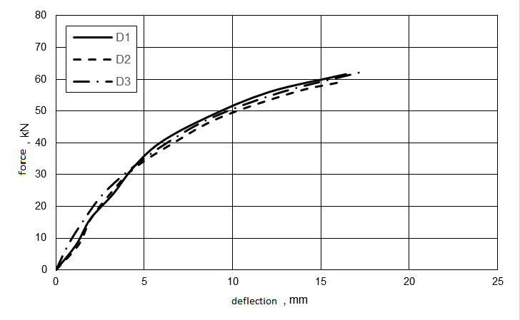
Fig. 1. Figure title
Mathematical formulas should be prepared in Microsoft Equation or the Microsoft Word equation editor. In the text, the patterns should be centered, leave one free line before and after the pattern. Patterns should be numbered consecutively from the left in round brackets.
σ = E ε (1)

The article should be divided in a clear way into chapters and subchapters, numbered one by one (eg 1. then 1.1 - only in two steps)

3. Conclusions
At the end of the article, conclusions should be presented.

Acknowlegements
A place to provide information on the sources of financing, substantive input of various entities that participated in the creation of the article.

References
Quotations in the text should be placed in square brackets. The bibliography should be numbered consecutively and sorted by the order of quoting. For each item
bibliographic reference should be made in the text of the article. Examples of the citation of various lithium positions are shown below. The bibliography should only use the Latin alphabet, in the case of a position in another alphabet, the description should be given in the form of transliteration.

- Youssef M.A., Analytical prediction of the linear and nonlinear behaviour of steel beams rehabilitated using FRP sheets, Engineering Structures 2006, 28, 903-911.
- Schwegler G., Seismic strengthening of unreinforced masonry buildings with carbon fibers, Publication of Federal Institute of Technology, Zurich, Switzerland, 1995.
- Tumialan J.G., Galati N., Namboorimadathil S.M., Nanni A., Strengthening of Masonry with FRP Bars, [w:] ICCI 2002, San Francisco, CA, June 10-12.
The title of the article in Polish
STRESZCZENIE:
Abstract in Polish.

SŁOWA KLUCZOWE:
3 to 5 keywords in Polish

Author's workplace, detailed address, e-mail address, orcid id
Coauthor's workplace, detailed address, e-mail address, orcid id

